https://dev303757.service-now.com/navpage.do
admin
Pun……
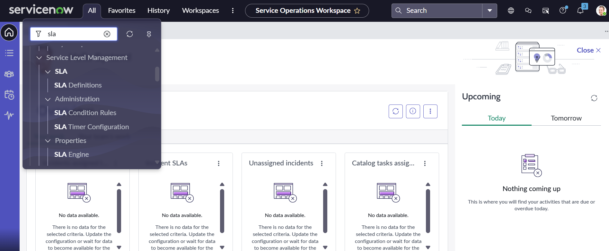
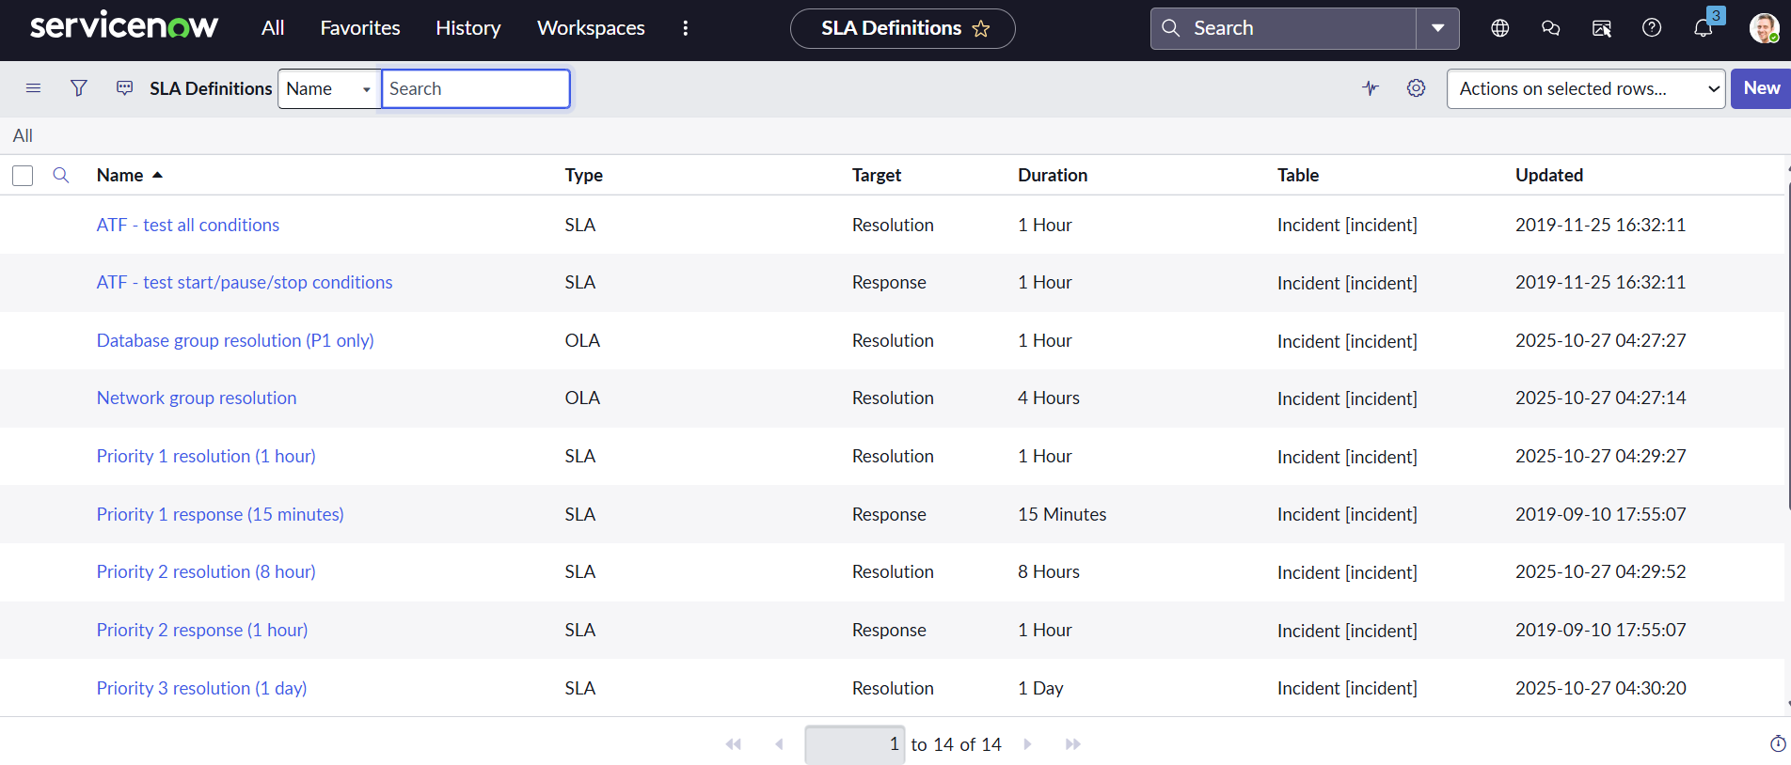

Priority 1 Resolution(1 hour)
Priority 1 Response (15 minutes)

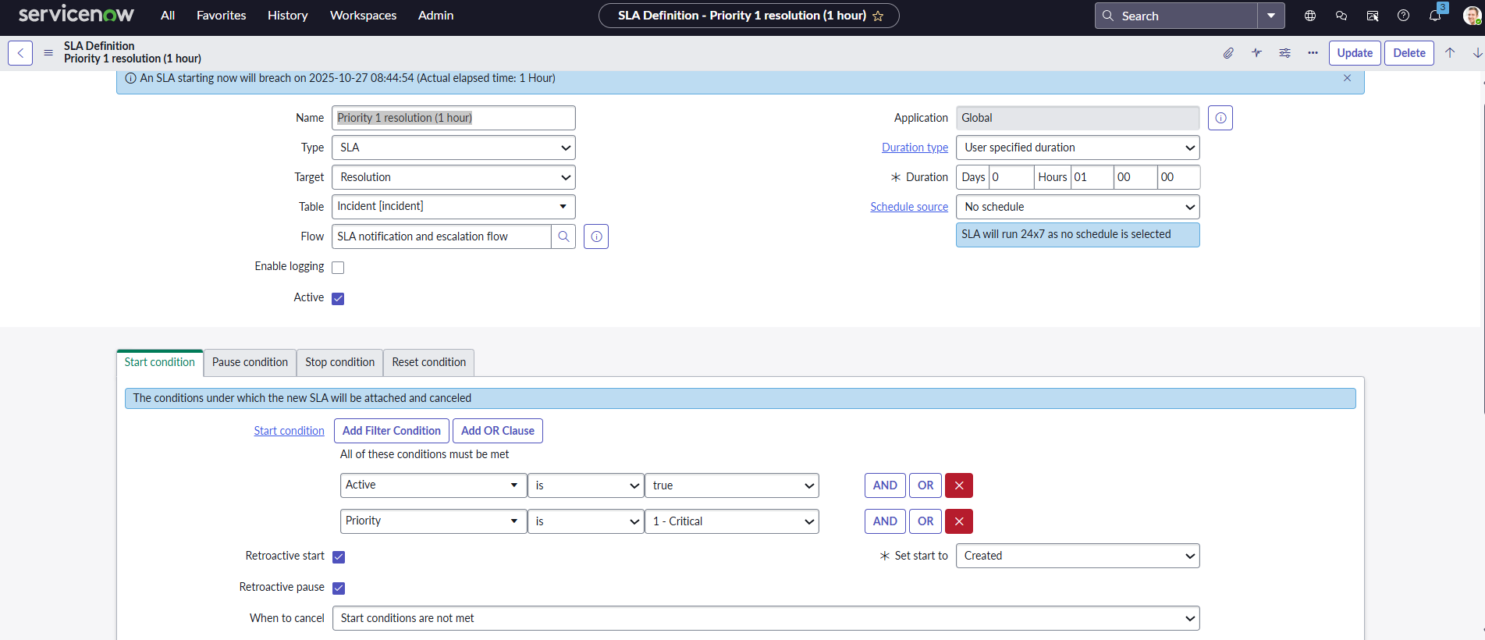
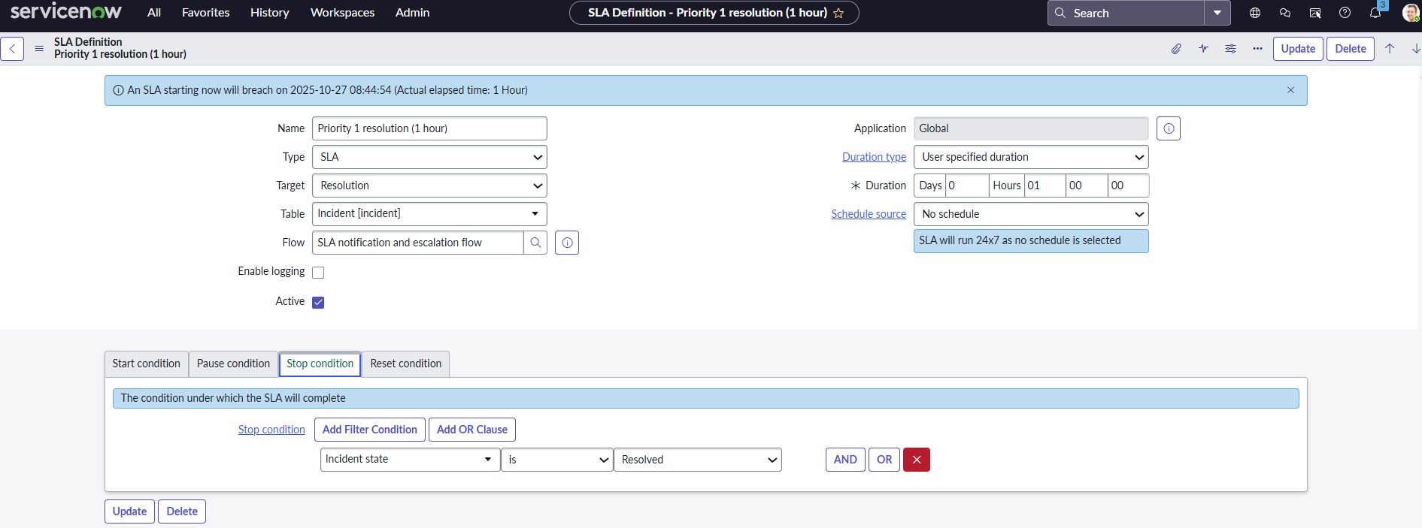
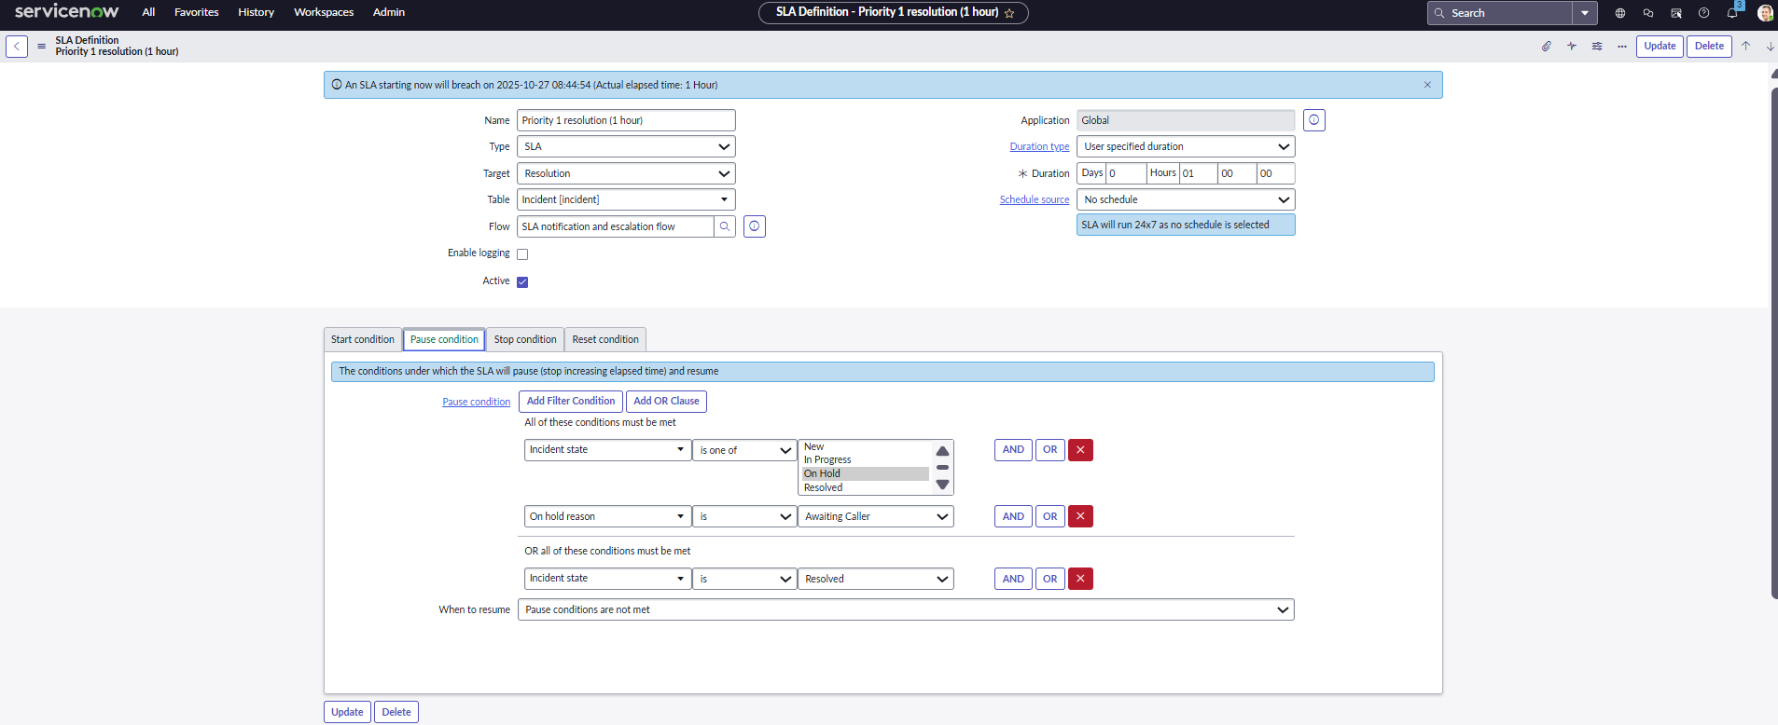

Priority 1 Response (15 minutes)
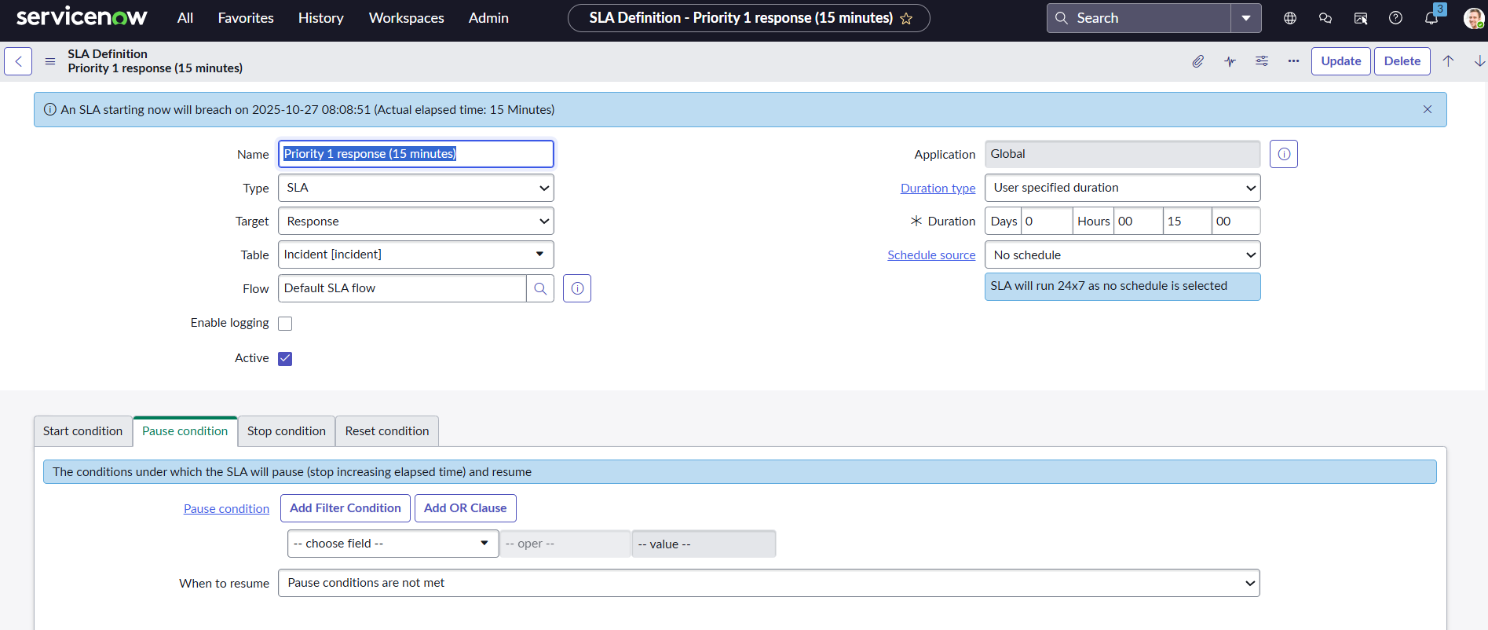
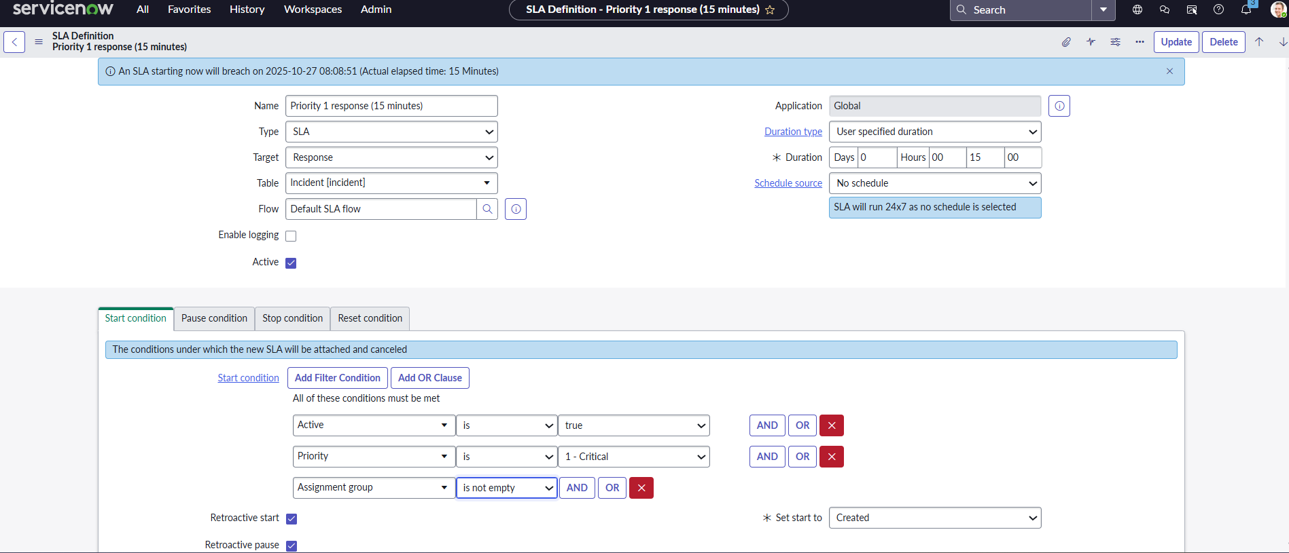
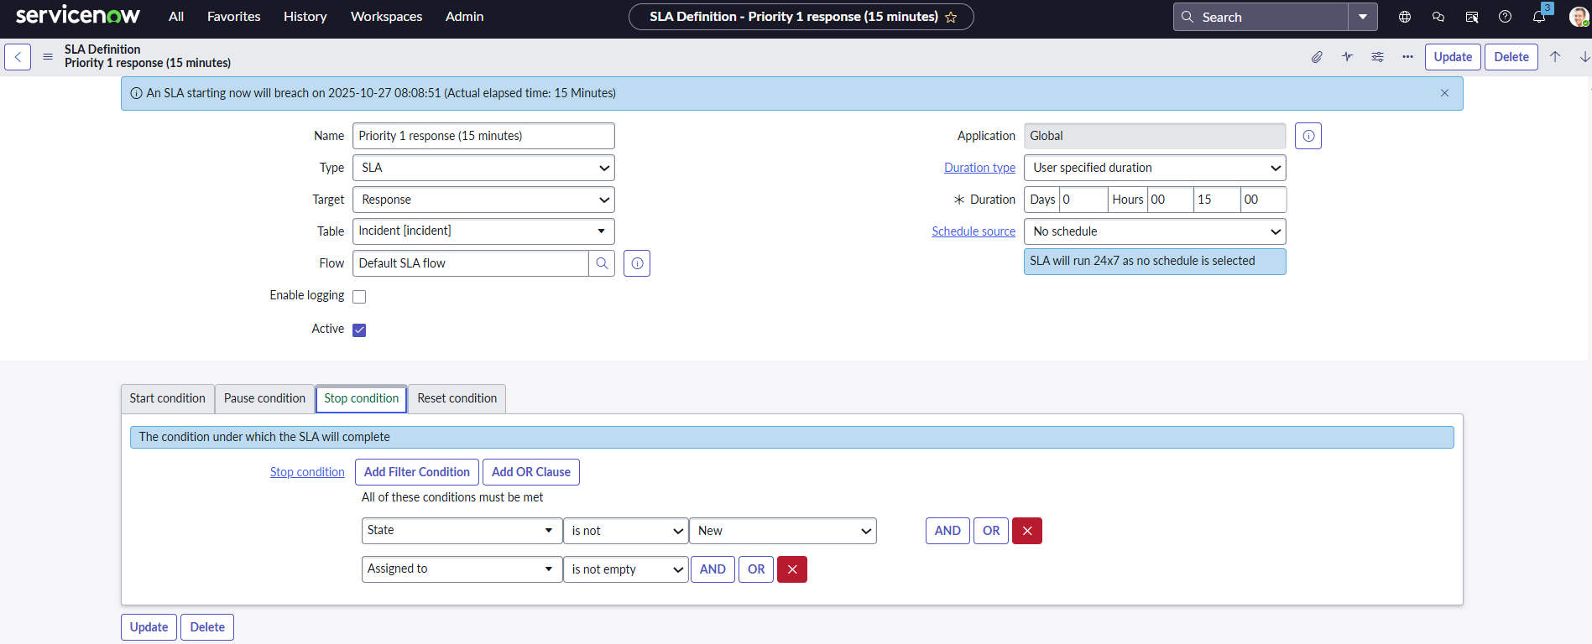

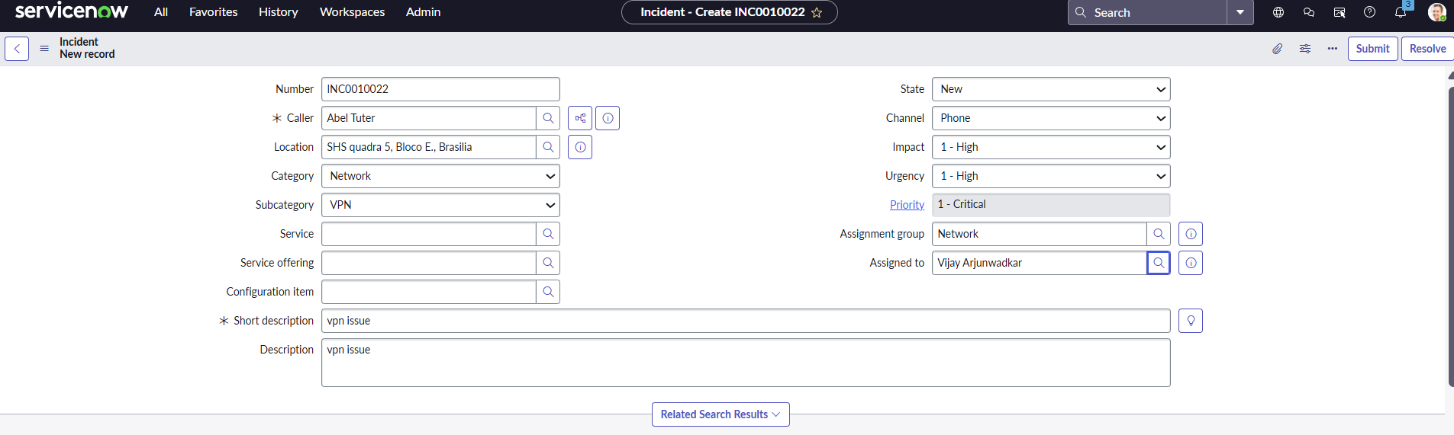
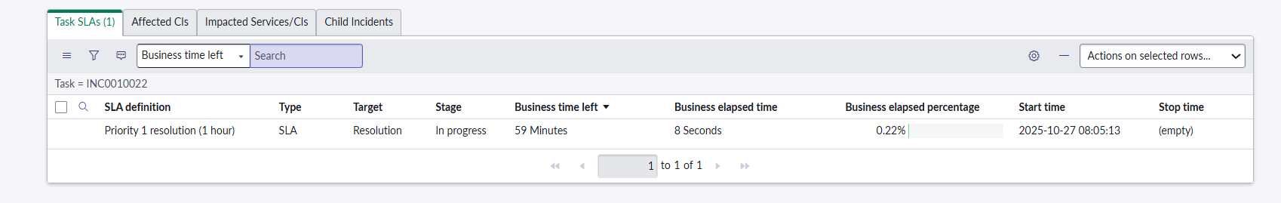
Fleet Management Case Study: LogisticStream 360
A company is building a system to collect sensor data from its 36000 trucks, which is stored in DynamoDB. The trucks emit 1KB of data once every hour
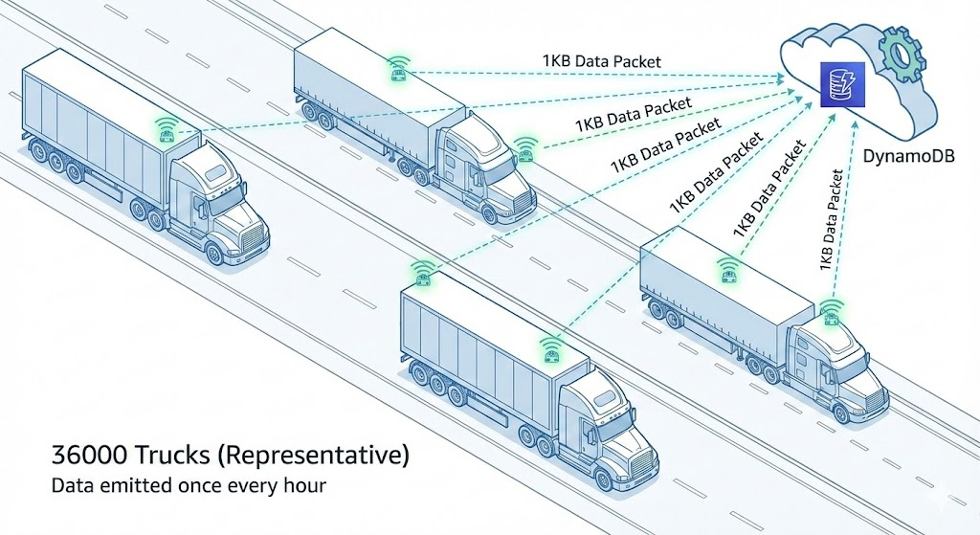
Case Study: 360-Degree Fleet Visibility for "LogisticStream"
1. The Scale & Business Challenge
LogisticStream operates a fleet of 36,000 heavy-duty delivery vehicles across a continental network.
- The Scale: Each vehicle sends a "Heartbeat" (GPS, Fuel, Speed, Engine Temp) every 1hr.
- The Load: 3,6000 messages per hr
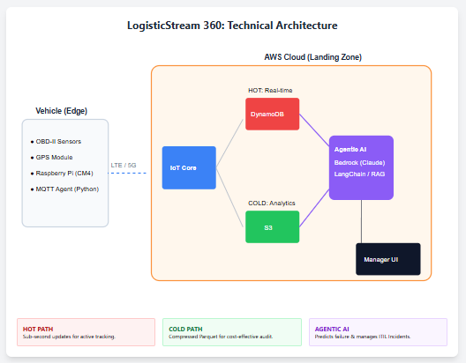
- The Goal:
1. Real-time Monitoring: Fleet managers must see the current status of any vehicle instantly.
2. Historical Analysis: Analysts need to look at fuel efficiency trends over the last 3 years.
2. The AWS Architecture: "Hot, Warm, and Cold" Paths
A. Ingestion: AWS IoT Core
- Action: 36,000 vehicles connect via MQTT.
- IoT Rules Engine: Uses a "Split Action" to send data to two different destinations simultaneously.
B. The Hot Path: Amazon DynamoDB (Real-Time State)
- Purpose: Provides sub-millisecond access to the "Current Status" of every vehicle.
- Architecture: The IoT Rule writes directly to a DynamoDB table.
- Key Strategy:
  - Partition Key: VehicleID
  - Sort Key: Timestamp (or a dedicated "LatestStatus" attribute).
  - TTL (Time to Live): We set a TTL of 24 hours. Data older than one day is automatically deleted from DynamoDB to keep the table lean and costs low, as the "Current State" is all that matters here.
C. The Warm/Cold Path: Kinesis Firehose -> S3 (Historical Data)
- Purpose: Long-term storage for big data analytics and auditing.
- Architecture: IoT Core sends data to Amazon Data Firehose.
- Firehose Transformation: Firehose batches the messages and converts them into Apache Parquet format using an inline AWS Lambda function.
- Storage: The Parquet files are saved in Amazon S3 partitioned by /year/month/day/hour/.
3. ITIL 4 Practice Mapping
Managing 36,000 moving assets requires strict adherence to ITIL 4 practices:
ITIL Practice | Fleet Management Application
IT Asset Management | Tracking the lifecycle of the IoT hardware installed in each of the 36,000 vehicles.
Monitoring & Event Management | Using DynamoDB Streams to trigger an alert if a vehicle's engine temperature exceeds a threshold.
Capacity Management | Monitoring the Write Capacity Units (WCU) of the DynamoDB table to ensure it scales as the fleet grows from 36k to 50k vehicles.
Service Validation & Testing | Ensuring that "Firmware over the Air" (FOTA) updates don't brick the vehicle sensors (Change Enablement).
4. Advanced "Agentic AI" Integration
Using the LangChain/Bedrock framework for a Fleet Manager:
- The Query: A manager asks, "Which vehicles in the Northern Region are at risk of missing their delivery window due to mechanical issues?"
- The Agent Logic:
  - Step 1: The Agent queries DynamoDB to find vehicles with "Engine Alerts."
  - Step 2: The Agent queries S3 (via Amazon Athena) to check the last 30 days of maintenance history for those specific vehicles.
  - Step 3: Amazon Bedrock (Claude 3.5) synthesizes the data: "Vehicle #TRK-992 has a high-heat alert and a history of radiator issues. Recommend rerouting its cargo to Vehicle #TRK-104 which is 5 miles away."

Priority 1 Response (15 Minutes) & Priority 1 Resolution (1 Hour)
In ITIL 4 and Service Management, these are known as SLA (Service Level Agreement) Targets.
Using your 36,000 Vehicle Fleet project, let's look at a "Critical System Failure" scenario to explain the difference between Response and Resolution.
The Scenario: "The Blackout"
The Event: Your AWS IoT Core stops receiving data from all 36,000 vehicles simultaneously.
This is a Priority 1 (P1) incident because the entire business is "blind."

1. Priority 1 Response (15 Minutes)
The "Response" timer starts the exact second the incident is created in ServiceNow.
- What it means: This is NOT the time to fix the problem. This is the "Acknowledgement" time.
- The Goal: A human (or a qualified On-Call Engineer) must claim the ticket and begin the investigation.
- The Action: * 0 minutes: Monitoring alert triggers a P1 Incident.
  - 5 minutes: The On-Call Cloud Architect receives a message on their phone.
  - 12 minutes: The Architect logs into ServiceNow and clicks "Accept" or "In Progress."
- Result: SLA MET. (The business knows someone is working on it).

2. Priority 1 Resolution (1 Hour)
The "Resolution" timer also starts when the ticket is created, but it represents the time to Restore Service.
- What it means: The service must be back up and running. A "Workaround" counts as a resolution even if the root cause isn't fixed yet.
- The Goal: The 36,000 vehicles must be able to send data again.
- The Action:
  - 15 minutes: Architect finds that an AWS Security Group rule was accidentally changed.
  - 40 minutes: The rule is reverted, and a "Heartbeat" signal is received from the first 100 trucks.
  - 55 minutes: Data flow is confirmed for all regions. The Architect resolves the ticket in ServiceNow.
- Result: SLA MET. (The business is back in operation).

Summary Table for your Course
Feature | Response (15 mins) | Resolution (1 hour)
Focus | Speed of Engagement | Speed of Recovery
Meaning | "I am looking at it." | "It is fixed / back online."
ITIL Practice | Incident Management | Service Request / Incident Mgmt
Success Metric | User feels heard/supported. | Business loss is minimized.

The "SLA Breach" (ITIL 4 Perspective)
- If the Architect takes 20 minutes to click "Accept," the Response SLA is Breached.
- If the data is still blocked after 65 minutes, the Resolution SLA is Breached.
In your LogisticStream 360 dashboard, a breach would trigger an automatic notification to the Service Level Manager, as a P1 breach usually involves financial penalties or safety risks for the fleet.
Explanation of below Screen Shots….
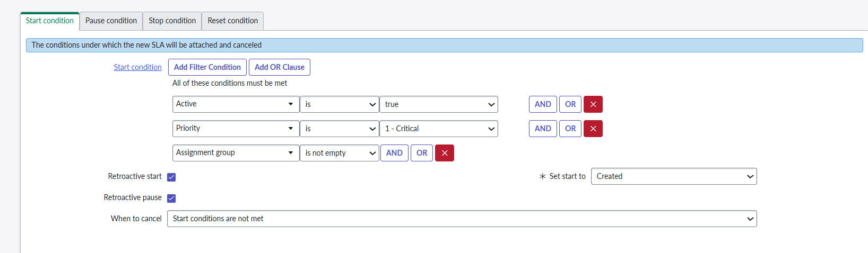
Analysis of the SLA Start Condition
The image displays the Start Condition tab, which defines when a new Task SLA record will be attached to an Incident.
1. Start Condition Filters
These are the criteria that must all be met simultaneously for the SLA to attach and start running:
Condition | Logic | Meaning
Active | is true | This ensures the SLA only starts on an Incident that is currently open or in process.
Priority | is 1 - Critical | This is the most crucial filter. The SLA only applies to P1 (Critical) incidents. If the Incident priority is P2 or lower, this SLA will not attach.
Assignment group | is not empty | This ensures that the SLA only starts after the Incident has been assigned to a responsible team. If the group is empty, the SLA won't start, preventing clock measurement while the ticket is unassigned.
In summary, this SLA is designed to track a Critical Incident (P1) that has been assigned to a team.
Auto Assignment rules can be configured….
2. Retroactive Settings (Crucial for Clock Start)
These settings determine when the clock effectively starts relative to the moment the conditions are met:
Setting | Status | Meaning and Impact
Retroactive start | Checked (Enabled) | This forces the SLA clock to use an earlier timestamp, rather than the moment the conditions above were met.
Set start to | Created | Since Retroactive start is enabled, the SLA clock will be set to the Creation date/time of the Incident, even if the Priority was changed to P1 30 minutes later. This ensures time spent before assignment is counted.
Retroactive pause | Checked (Enabled) | This tells the system to review the history of the Incident. If the Incident was ever in a Pause Condition state (as defined in the Pause condition tab) before the SLA started, that historical pause time will be subtracted from the total elapsed time.

Since Retroactive start is enabled, the SLA clock will be set to the Creation date/time of the Incident, even if the Priority was changed to P1 30 minutes later. This ensures time spent before assignment is counted.
This statement is explaining how the Service Level Agreement (SLA) clock behaves when an incident ticket's Priority is increased, and the feature Retroactive start is enabled.
Here's a breakdown of what that means for your scenario:
Understanding Retroactive Start
When Retroactive start is enabled for an SLA, it means the timer for meeting the SLA does not begin when the ticket is classified with the final, highest priority (P1 in your case). Instead, the clock is set back to the absolute beginning.
- Scenario:
  - Ticket Created at 10:00 AM with P2.
  - Ticket Priority Changed to P1 at 10:30 AM.
- SLA Clock Start: Because Retroactive start is enabled, the SLA clock for the P1 SLA does not begin at 10:30 AM. It is retroactively started at 10:00 AM (the Creation date/time of the Incident).
- What this ensures: The statement, "This ensures time spent before assignment is counted," highlights the core benefit. The 30 minutes between 10:00 AM (creation) and 10:30 AM (P1 classification) is a period where the incident was active and should have been worked on. By starting the clock at 10:00 AM, the SLA system forces the P1 clock to account for those initial 30 minutes.
Key Takeaway
The system is designed to prevent teams from gaining extra time by initially misclassifying a high-priority incident.
Time Event | Priority in System | SLA Clock Status (P1 SLA)
10:00 AM (Incident Created) | P2 | Starts running (Retroactive Start)
10:30 AM (Priority Changed) | P1 | Continues running, 30 minutes already elapsed
In short, the P1 SLA's timer started running the moment the ticket was created, not the moment its priority was correctly set to P1.
That is exactly the consequence of Retroactive start being enabled.
The team has lost 30 minutes of their available time because the SLA clock was set back to the moment the ticket was created.
Here is the breakdown of the calculation:
Metric | Time | Notes
P1 SLA Duration | 4 hours | This is the total time allowed for a P1 incident.
Incident Creation Time (P2 Start) | 10:00 AM | This is when the Retroactive Start clock begins.
P1 Priority Change Time | 10:30 AM | The moment the priority was correctly identified as P1.
Time Elapsed Before P1 | 30 minutes | This is the time lost against the P1 SLA.
Time Remaining on P1 SLA | 3 hours and 30 minutes
SLA Due Time | 2:00 PM

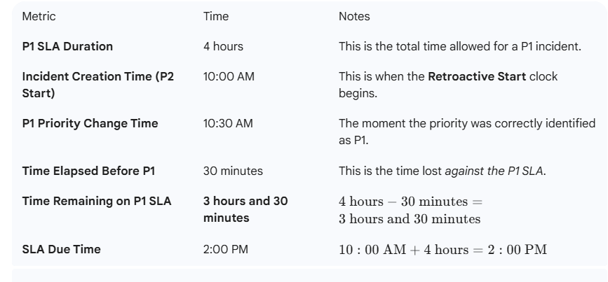

3. Cancellation Policy
Setting | Value | Meaning
When to cancel | Start conditions are not met | This is the standard setting. If the Incident no longer meets any of the three start conditions listed above (e.g., if the Priority is downgraded from P1 to P2), the SLA will be immediately cancelled and removed from the Incident.
This entire configuration ensures that the SLA is precisely targeted at P1 (Critical) incidents and measures performance from the moment the ticket was created in the system.
🛑 SLA Cancellation Logic
The rule explains what happens to an active SLA (Service Level Agreement) when the conditions that originally triggered it are no longer met.
1. The Premise: "Start Conditions are not met"
- SLA Start Conditions: Every SLA is tied to specific criteria. For a P1 Resolution SLA, the start condition is usually something like: "Priority is P1" AND "Status is New/In Progress."
- Triggering the SLA: When a ticket meets all these defined "Start Conditions," the SLA is attached and starts running.
2. The Action: "The SLA will be immediately cancelled and removed from the Incident."
- This means the running SLA clock stops, and the SLA record itself is typically removed from the incident's tracking list.
- The SLA is considered "stopped" and "unbreached" at the time of cancellation, and the time spent on it is not counted toward a failure for that specific metric.
3. The Example: "if the Priority is downgraded from P1 to P2"
- Let's assume the P1 SLA's start condition is "Priority is P1."
- If the incident is currently P1, the P1 SLA is active and ticking.
- If a team reviews the incident and changes the priority to P2 (Downgrade), the "Priority is P1" condition is no longer met.
- Result: The P1 SLA is instantly cancelled.
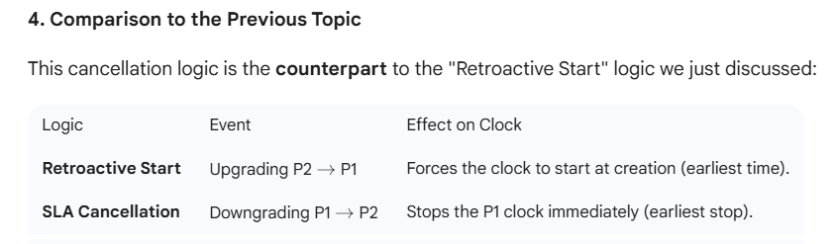

Here is how the cancellation works using your timeline, assuming the incident is downgraded to P2 at 11:00 AM.
P1 SLA Cancellation Example
This scenario picks up right after the P1 SLA started running, and then the priority is lowered.
Initial State (Before Cancellation)
Metric | Value | Notes
P1 SLA Duration | 4 hours | Target resolution time.
SLA Start Time | 10:00 AM | Retroactive start (at creation).
SLA Due Time | 2:00 PM
Time Elapsed (10:00 AM to 11:00 AM) | 1 hour
Time Remaining on P1 SLA (at 11:00 AM) | 3 hours

Event | Time | Impact on P1 SLA
Priority Downgrade | 11:00 AM | The incident's priority is changed from P1 -> P2.
Result | Immediate Cancellation | The P1 SLA is stopped, and its record is removed from active tracking.

At the moment of cancellation (11:00 AM), the P1 SLA is recorded as met (not breached), as the team changed the priority before the 2:00 PM due time.
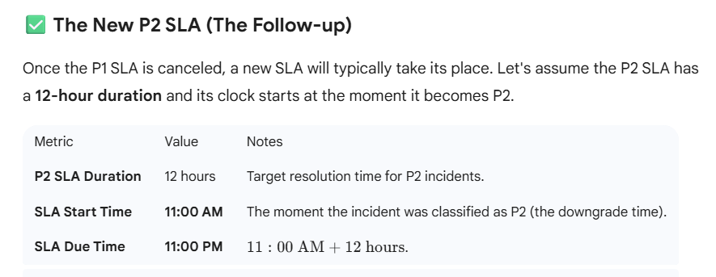

The urgency is reduced, and the team now has a much longer, new timeline based on the P2 requirements, starting fresh from the downgrade time.
https://www.youtube.com/watch?v=kmbZHtmnyBI
ServiceNow - How to Implement The SLA Retroactive Pause Condition in London - THE REBOOT

The difference between Business Time Left and Business Elapsed Time is all about what point in the clock you are measuring against.
They are both system-calculated fields on the Task SLA record that factor in the SLA Schedule (the working hours).
Here is the breakdown of the difference:

Business Elapsed Time vs. Business Time Left
Field | What it Measures | Calculation Logic
Business Elapsed Time | How much time has passed (in working hours) since the SLA clock started. | Calculated from the SLA Start time up to the current moment (or the stop time, if the SLA is complete).
Business Time Left | How much working time remains before the SLA breaches. | Calculated from the current moment (or the last pause time) up to the SLA Deadline (the Planned End Time).

Deeper Look at Each Field
1. Business Elapsed Time
This field answers: "How long have we been working on this, according to our SLA schedule?"
- It is the total duration, in seconds (which is then converted to HH:MM:SS), that the Task SLA record was in a non-paused state, only counting time within the defined schedule (e.g., 9:00 AM to 5:00 PM, Monday-Friday).
- Example: If an SLA starts at 9:00 AM on Monday with a 24/5 schedule, and it's now 11:00 AM on Monday, the Business Elapsed Time is 2 hours.
2. Business Time Left
This field answers: "How much working time do we have before the deadline?"
- This is the total duration, in seconds, remaining between the current time and the SLA's Planned End Time (the deadline), only counting time within the defined schedule.
- Example: If your SLA has a 4-hour resolution target and you have already accumulated 1 hour of Business Elapsed Time, then your Business Time Left is 3 hours.
- When the SLA clock is running, this number constantly decreases. Once it hits zero, the SLA has breached.
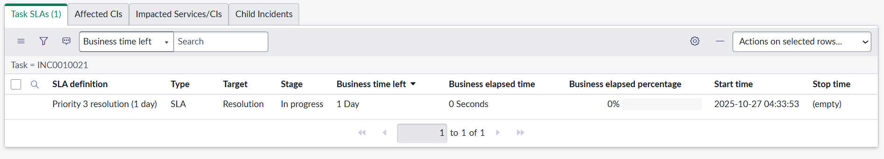
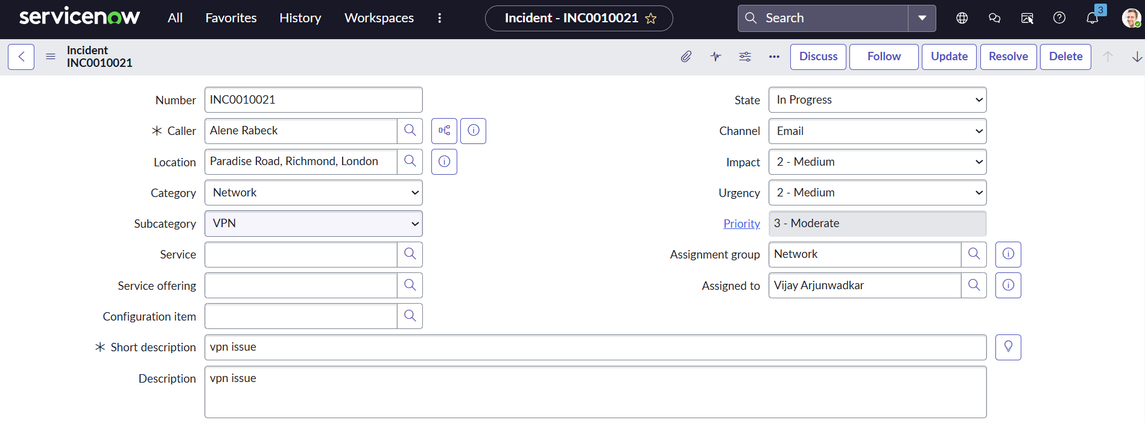

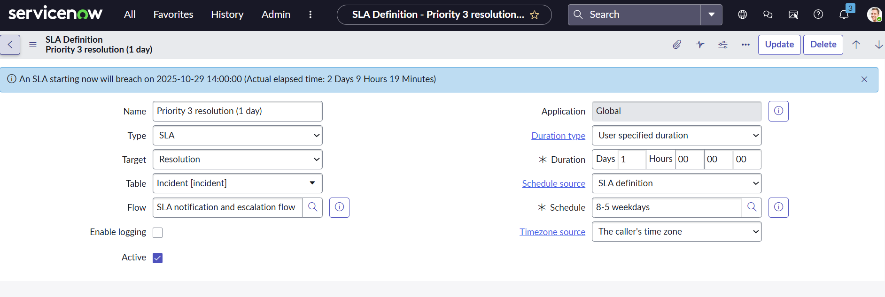
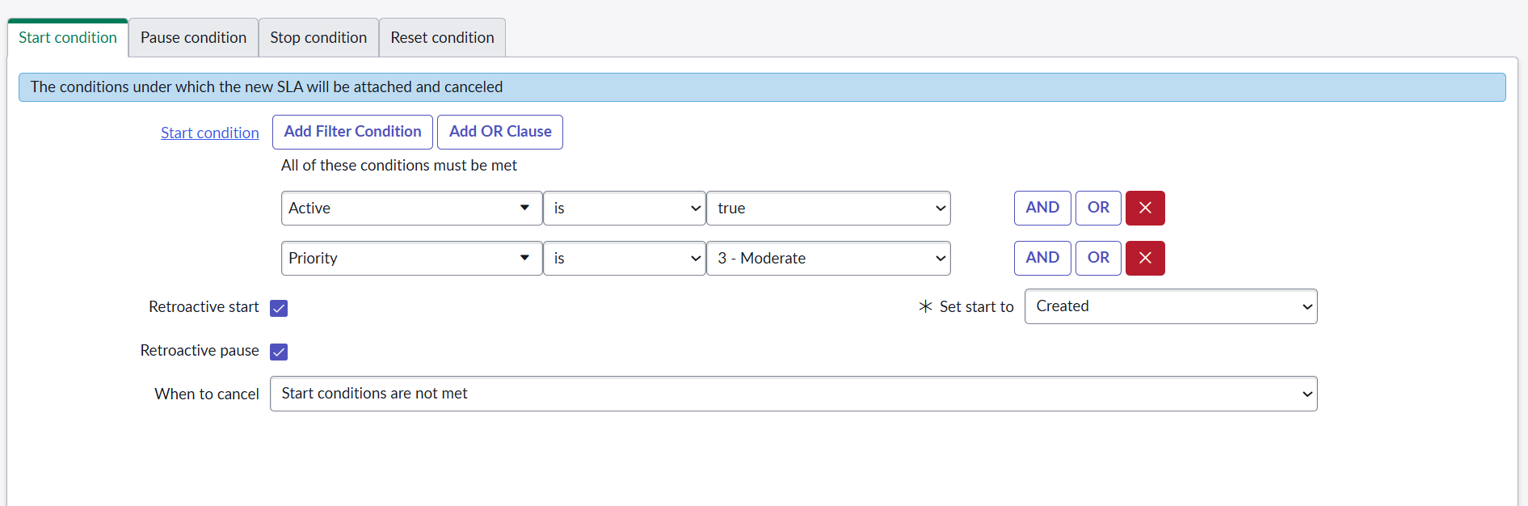
The Active field on the SLA Definition form is a boolean (true/false) flag that determines whether or not the SLA definition can be used by the system to create new Task SLA records.
Here is a breakdown of its two states:

The Purpose of the Active Field
1. Active = True (Checked)
- Status: The SLA definition is operational.
- Effect: The system will evaluate this SLA definition against new and updated Incident records. If an Incident meets the SLA's Start Conditions, a new Task SLA record will be created for that Incident, and the clock will begin running.
2. Active = False (Unchecked)
- Status: The SLA definition is dormant or retired.
- Effect: The system will not check this definition against any new or updated Incidents. No new Task SLA records will be created from this definition.
Why You Would Set an SLA to Inactive
You rarely delete an SLA definition, even if you stop using it, because deleting it could affect historical reporting. Instead, you set it to Inactive in these scenarios:
- Retirement: If your organization moves to a new set of SLAs (e.g., changing the targets from 4 hours to 3 hours), you mark the old 4-hour SLA as Inactive. This prevents new incidents from being tracked against the outdated target.
- Testing/Drafting: When you are creating a new SLA definition and are still testing its conditions and schedule, you should keep it Inactive. This ensures the system doesn't start applying it to production records prematurely.
- Temporary Disablement: If an SLA is causing performance issues or has been temporarily suspended due to a major business event, you can quickly deactivate it without losing the configuration.
In summary: The Active field is the master switch that controls whether an SLA Definition is currently enforcing service targets in your production environment.

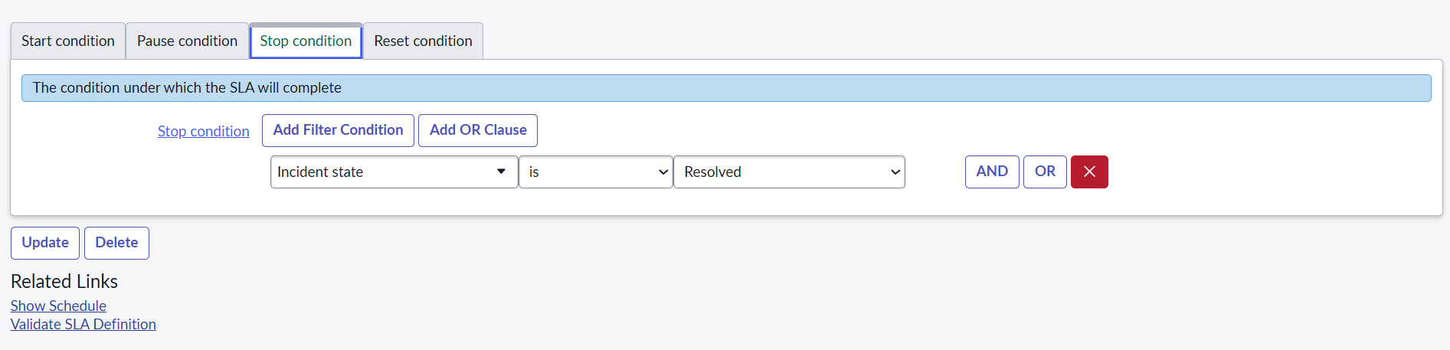
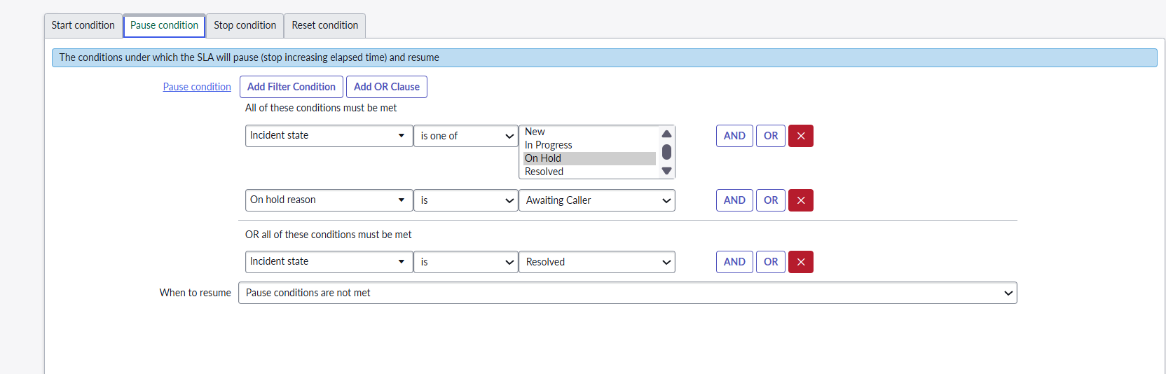
the SLA Breakdown Definition is a powerful feature in ServiceNow for advanced SLA configuration, especially in larger organizations!
The SLA Breakdown Definition allows you to use different schedules, targets, and even different SLA definitions based on the value of a specific field on the Task record (like Incident).
In essence, it allows one single, simple SLA to behave like multiple SLAs without having to create dozens of complex individual definitions.

How the Breakdown Definition Works
Instead of checking the Incident record directly for the schedule and duration, the SLA Definition checks the Breakdown Definition first.
1. The Trigger Field
You select a field on the main SLA Definition form called the Breakdown Field. This is the field whose value determines the SLA's behavior.
- Common Breakdown Fields:
  - Assignment Group: Different teams have different service expectations (e.g., the Network team has a 4-hour target, but the Desktop team has a 6-hour target).
  - Location/Country: Different geographical regions have different business hours (schedules).
  - Configuration Item (CI): Critical servers might have a 1-hour resolution target, while non-critical assets have a 1-day target.
2. The Breakdown Record
For each possible value of the Breakdown Field (e.g., if the Breakdown Field is Assignment Group, then each individual group like "Network," "Database," "Application Support" is a value), you create a corresponding Breakdown Record.
This Breakdown Record allows you to override the main SLA settings for that specific value:
Breakdown Field Value | You Can Override the Main SLA's...
"Network" Group | Schedule (e.g., use 24x7 schedule)
"Database" Group | Duration (e.g., set the target to 4 hours)
"Application" Group | Retroactive Start settings
3. The Execution
When an Incident starts an SLA:
- It identifies the main SLA Definition.
- It looks at the value in the Breakdown Field on the Incident (e.g., the Assignment Group is "Network").
- It finds the matching SLA Breakdown Record for "Network."
- It uses the Schedule and Duration defined in that Breakdown Record to calculate the deadline, overriding the settings from the main SLA Definition.
Example Scenario
Imagine you have one main SLA Definition called "P1 Incident Resolution - Global."
If you set the Breakdown Field to Assignment Group, you can create these breakdown records:
Breakdown Record (Assignment Group) | Duration Override | Schedule Override
"Tier 1 Support" | 8 Hours | 8x5 Business Schedule
"Network Operations" | 4 Hours | 24x7 Schedule
"APAC Team" | 6 Hours | APAC Business Schedule
This single configuration ensures the correct, locally-specific service target is applied automatically based on which team is currently working on the incident.
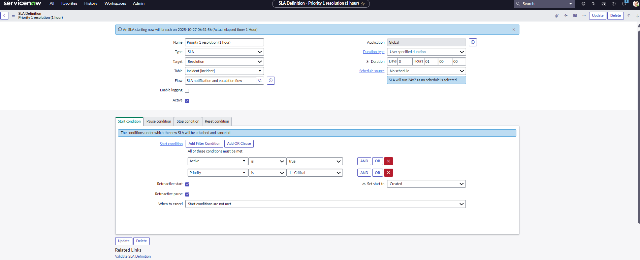
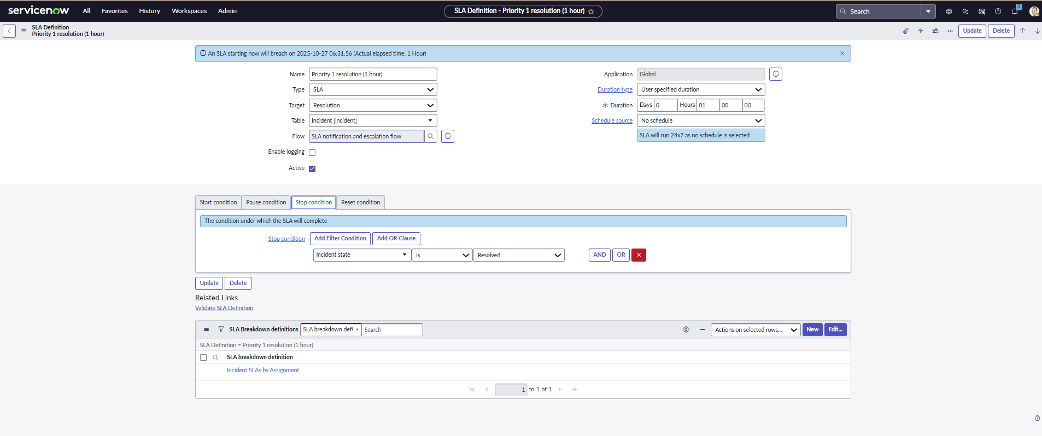
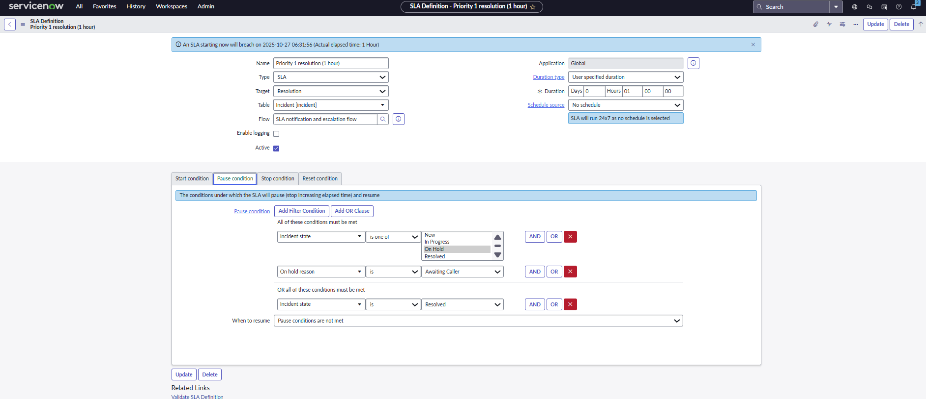

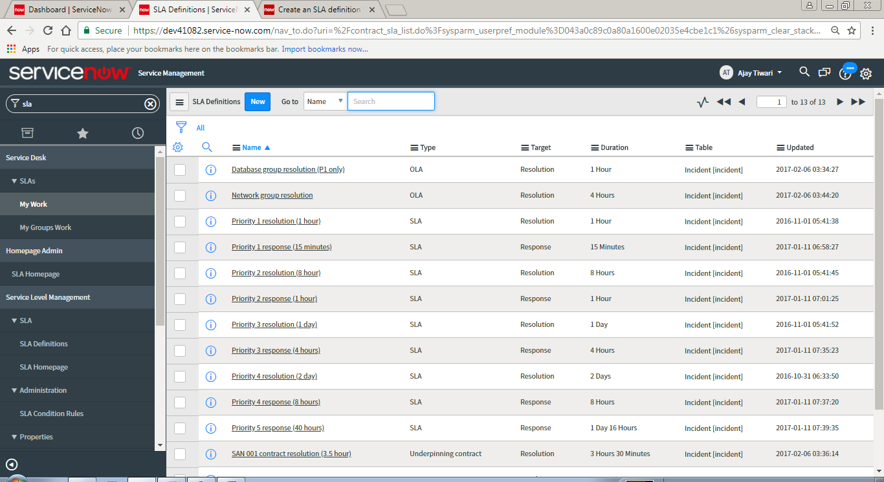
SLA Definition form is displayed
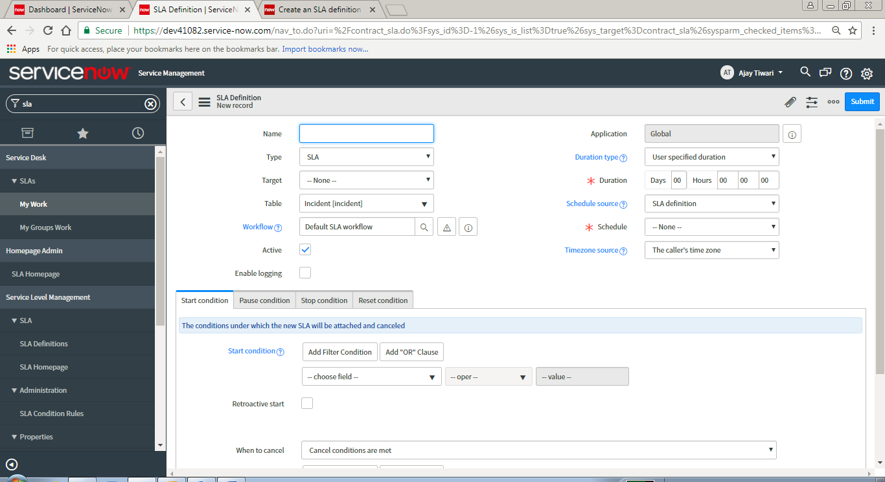
- SLA for end users
- OLA inside (IT) department
- UC with external people (vendors)

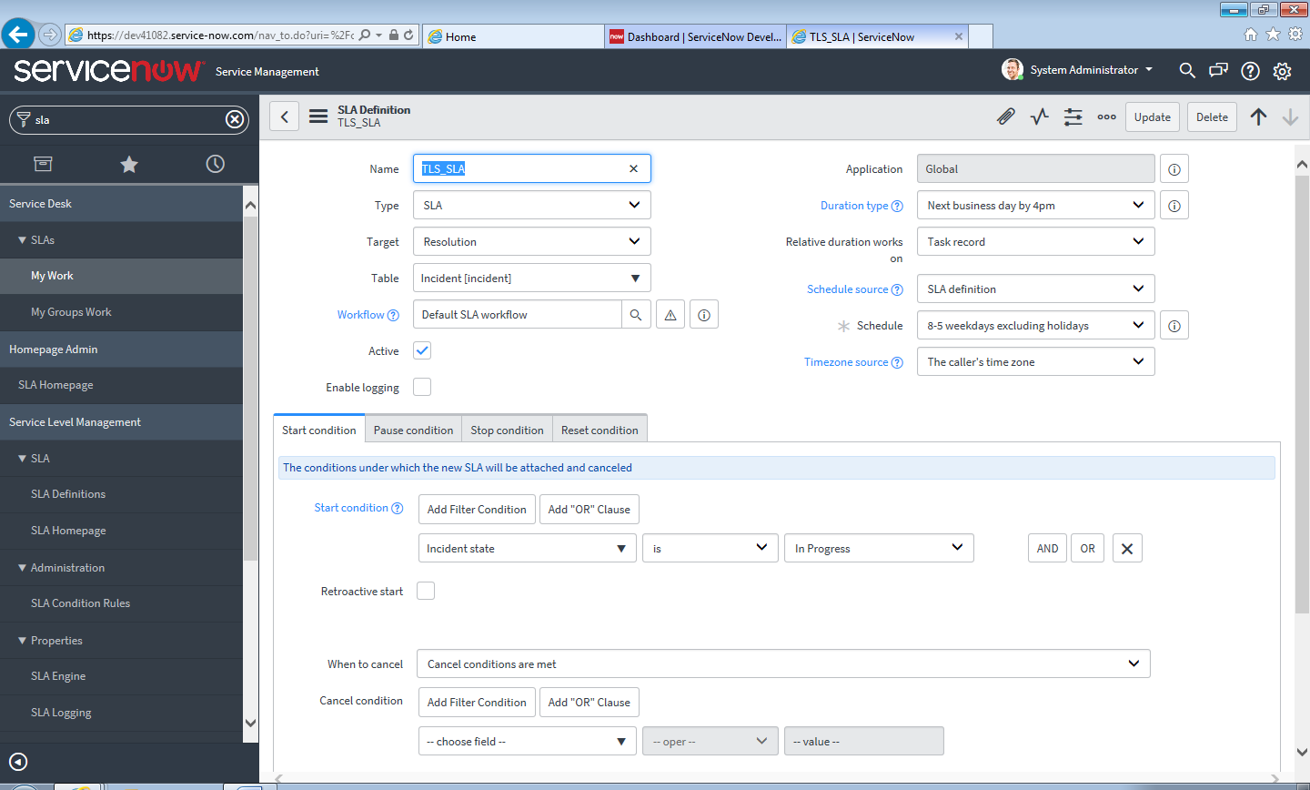

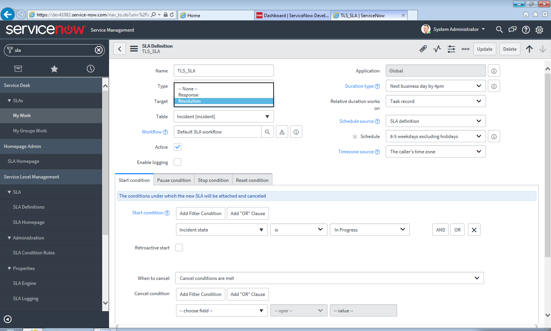
SLA Response time <= SLA Resolution Time
Response-It is the time in which the Ticket is Acknowledged or Assigned to a Team.

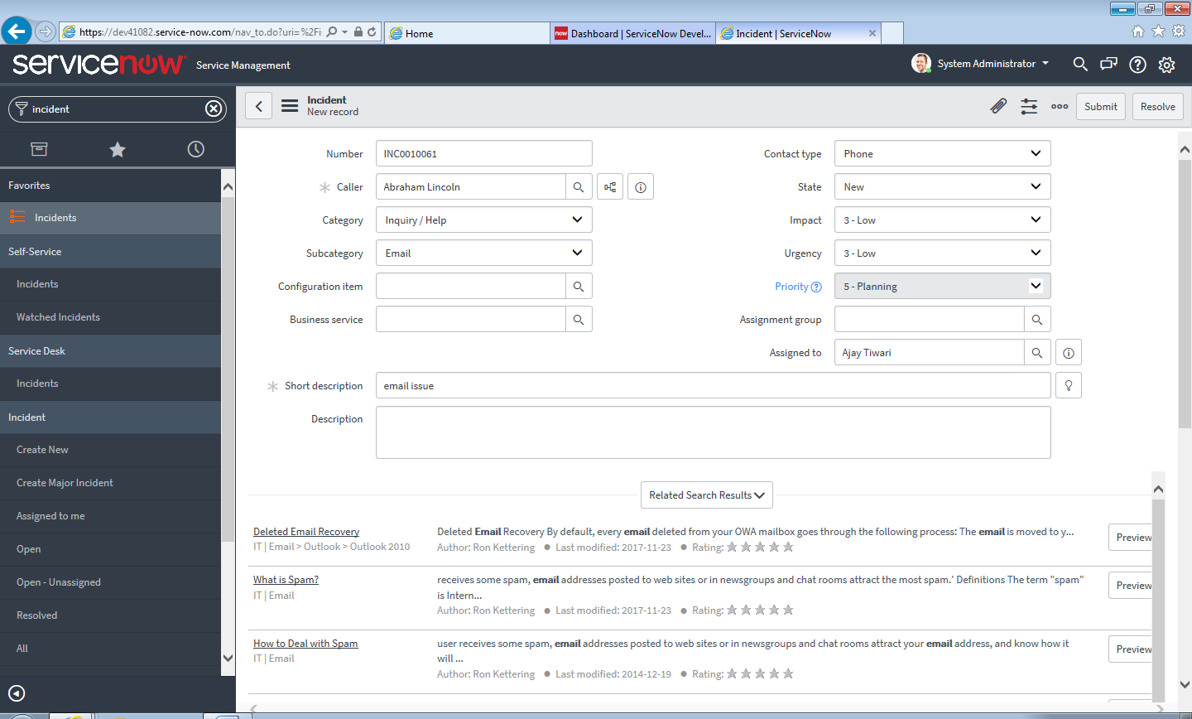
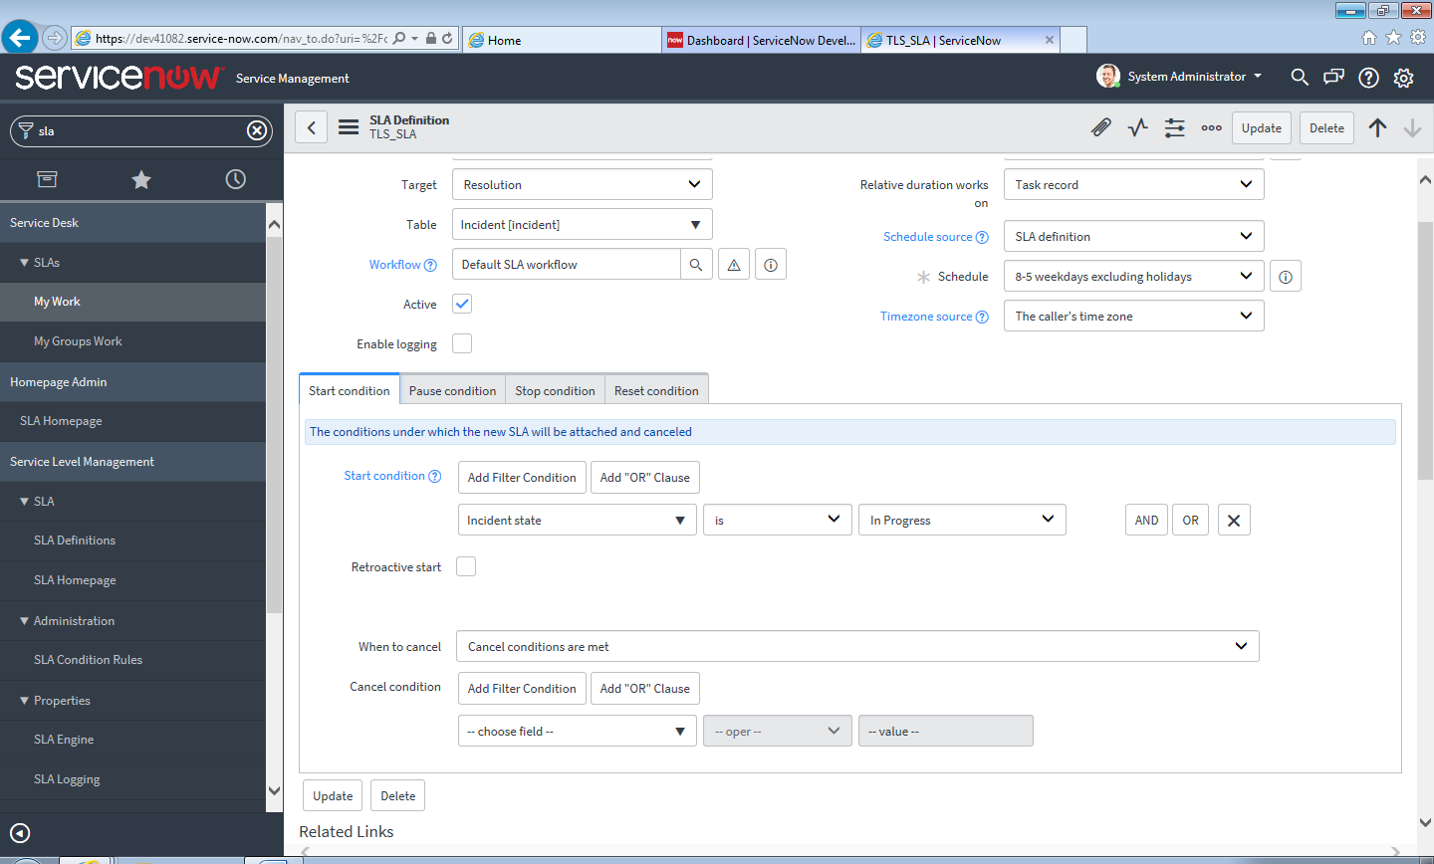
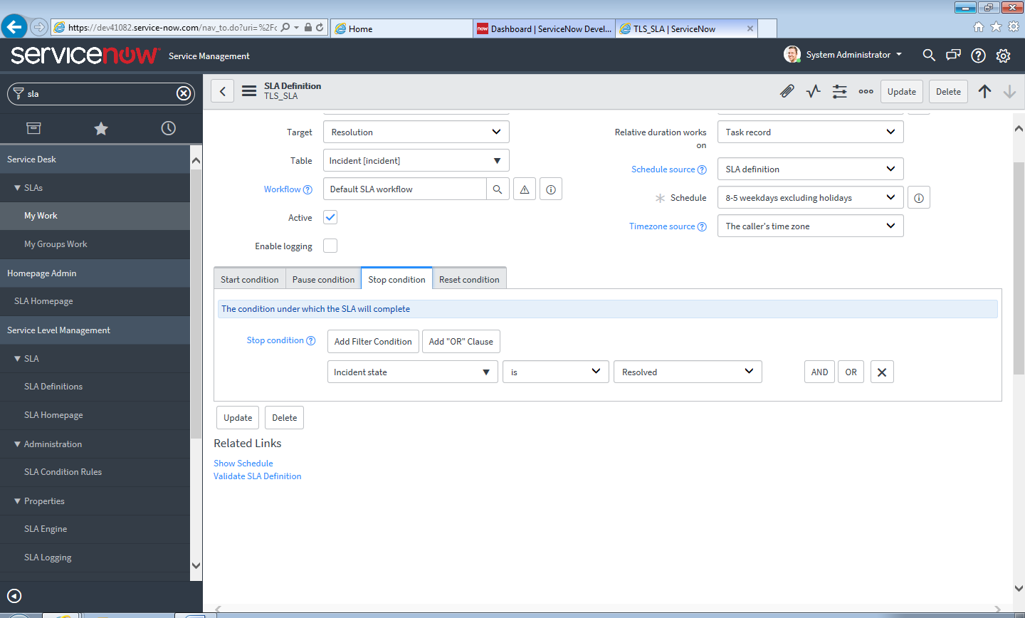
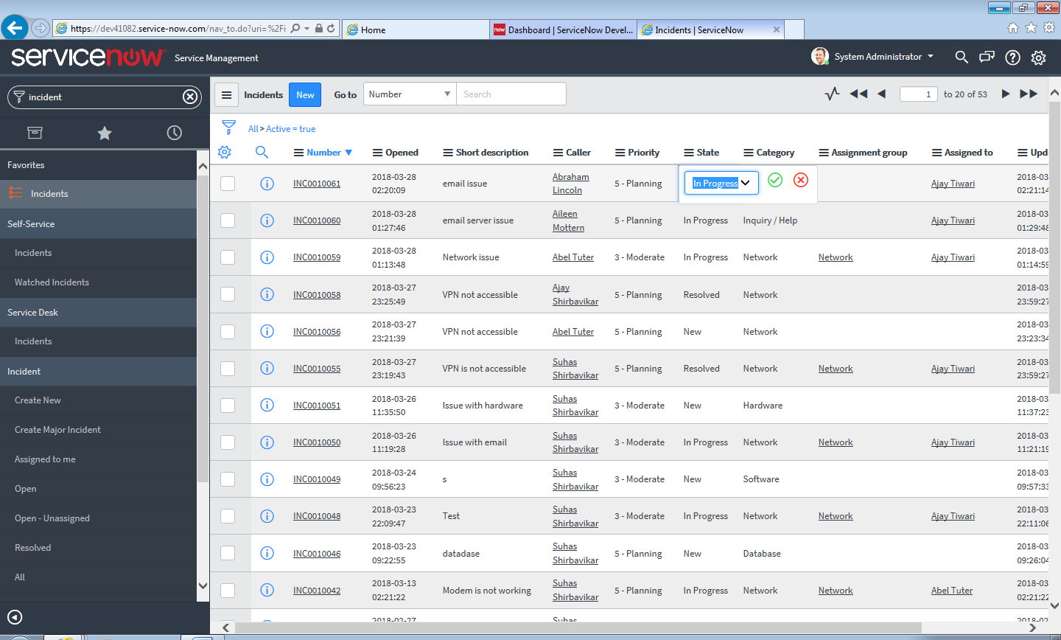
SLA clock will start …..because State is InProgress
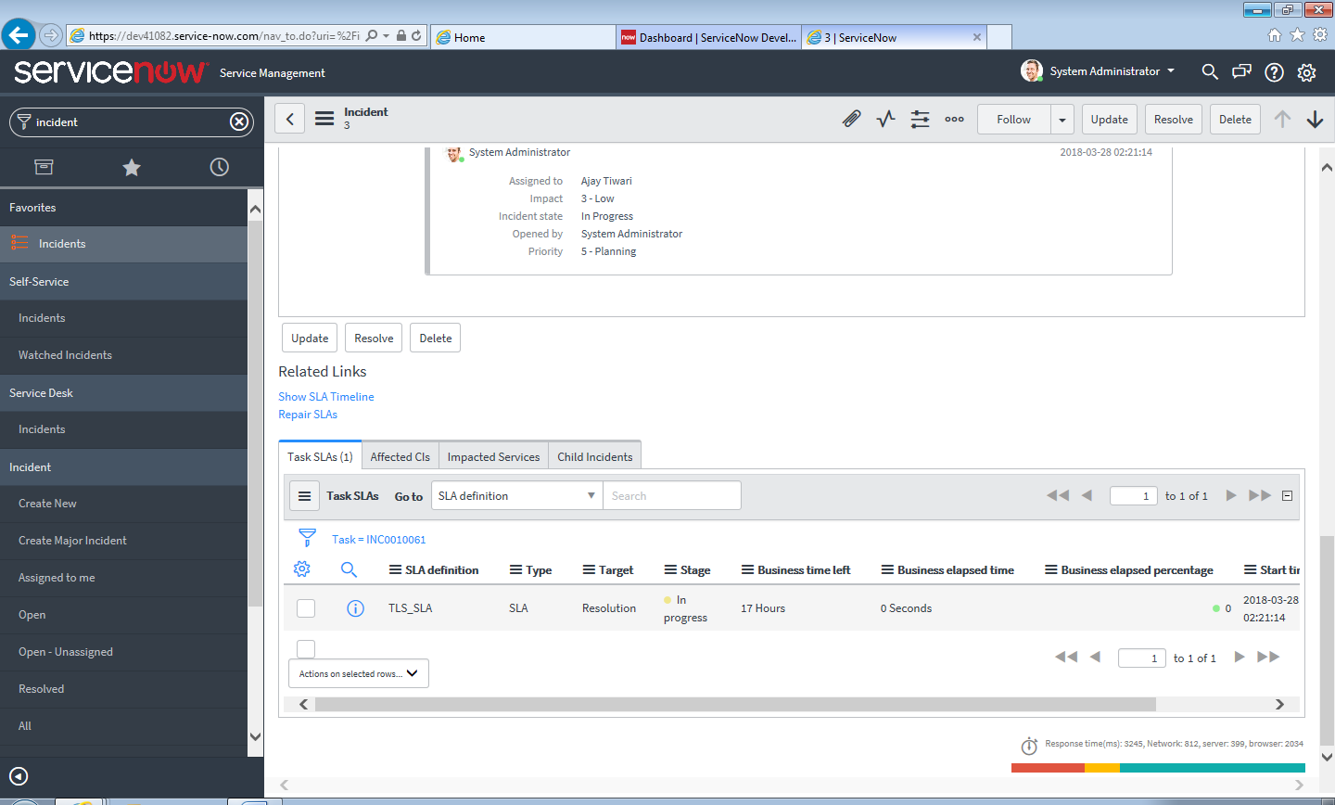
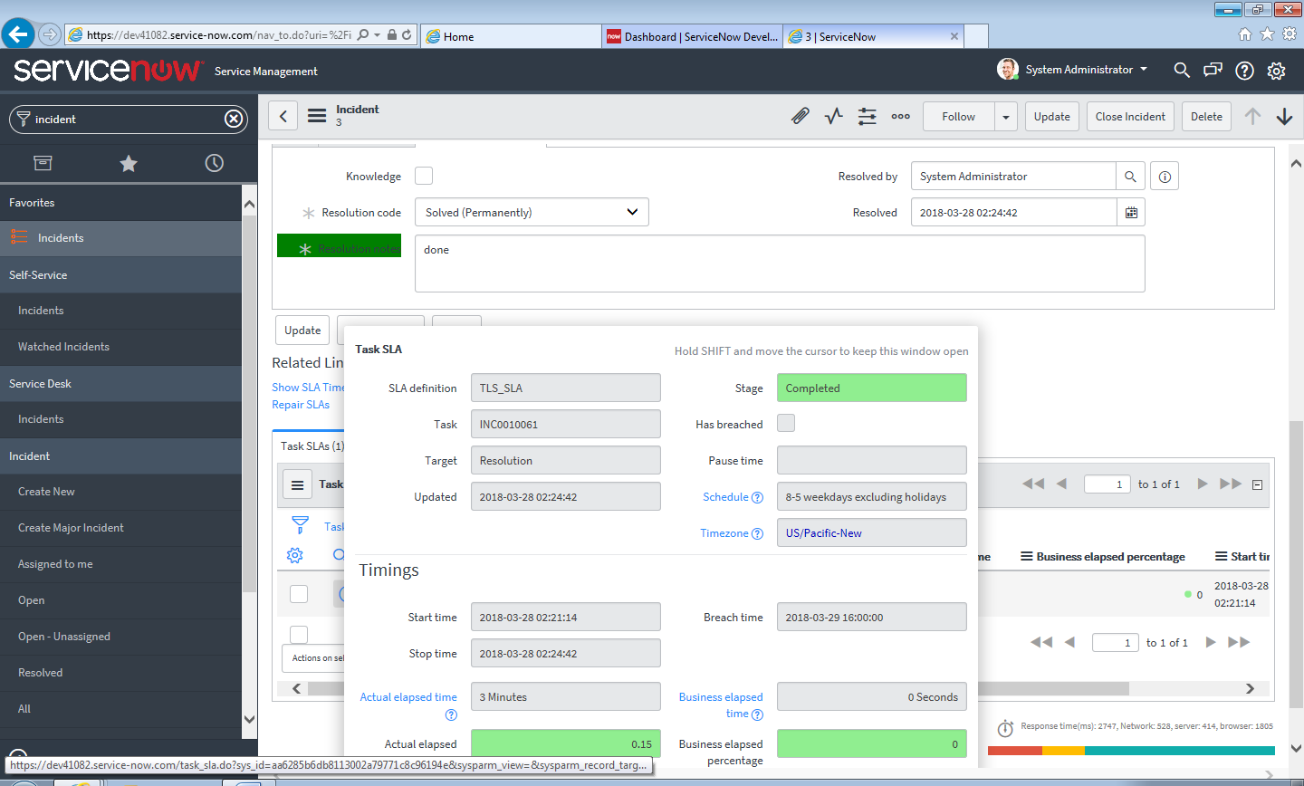

The concept of Retroactive Start is a crucial, yet sometimes confusing, setting in ServiceNow SLA Definitions.
It essentially means the SLA clock should be considered as having started before the actual SLA record was created or the conditions were met in the system.
Here is a breakdown of what it is, when it's used, and how it works:

What is a Retroactive Start?
Retroactive Start is a setting on an SLA Definition that allows you to start the SLA clock using the timestamp of an earlier event on the Task record, rather than the moment the SLA's Start Condition was first met.
When is it used?
You use retroactive start primarily in scenarios where the clock should logically start based on an event that happened before the Incident (or other Task) was formally created or categorized in the system.
The most common scenario is:
A user calls the Service Desk and reports an issue, but the agent takes 15 minutes to fully categorize and save the Incident record. The service level should be measured from the time the user first reported the issue, not when the agent hit "Save."
How it Works (The Set Start To Field)
When you check the Retroactive start checkbox on the SLA Definition, a new field appears called Set Start To. This field lets you select which timestamp the SLA clock should use as its true start time.
Common choices for the Set Start To field include:
Option | Description | Effect on SLA Start Time
Created | The exact date and time the Incident record was first created in the system. | Used when the SLA should measure from the moment the record was logged.
Opened | The date and time the Incident was moved to the Opened state. | Used when the SLA should start when a human agent first took ownership or officially acknowledged it.
Field (e.g., Active, Priority) | The date and time a specific field (like Priority or Impact) was set to a particular value. | Useful for SLAs that only begin when the priority is escalated.
Summary Example
- SLA Definition: "Resolution SLA (2-Hour)" with Start Condition = [Priority] [is] [P1].
- Retroactive Start is checked, and Set Start To is set to Created.
- An agent creates a new Incident at 10:00 AM. Its priority is initially P4.
- At 10:30 AM, the agent changes the Priority to P1. This meets the Start Condition.
Result:
- Without Retroactive Start: The SLA clock starts at 10:30 AM.
- With Retroactive Start: The SLA clock is "rewound" and starts at the Created time, which is 10:00 AM.
This ensures your service delivery performance is measured against the full time the issue has existed, not just when the system was updated.
That's a very practical question! In professional IT Service Management (ITSM) environments, using Retroactive Start is generally the preferred method for measuring service delivery, especially for critical SLAs.
Here is why and which option is usually chosen:

Why Retroactive Start is Preferred
The core purpose of an SLA is to measure service from the user's perspective, not just the technician's or the system's perspective.
1. Accuracy and Accountability
The time the user first feels the pain (when they contacted the service desk or when the issue started) is the true start of the clock. If an agent takes 10 minutes to process and save the ticket, those 10 minutes should still count against the SLA target. Retroactive start ensures this accountability.
2. Avoiding Gaming the System
Without a retroactive start, agents might be tempted to delay saving or correctly prioritizing a ticket until they are ready to start working on it, effectively giving themselves a head start on the SLA clock.
3. Reflecting the Actual Service Window
For external or business-facing SLAs, the contract often specifies that the clock starts when the incident is logged. Using a retroactive start tied to the creation time aligns the system's tracking with the formal business agreement.

Which "Set Start To" Value is Most Common?
When Retroactive Start is enabled, the most commonly preferred option for the Set Start To field is:
Preferred Option | Database Field | Context and Why It's Used
Created | sys_created_on | Most common for initial response/resolution SLAs. This sets the start time to the exact moment the Incident record was inserted into the database, regardless of what state or priority it was in. This is the earliest, most objective timestamp available and aligns with when the user initially logged the ticket (via self-service or phone call).
Less Common, but Still Important, Options:
Option | Database Field | When It Is Used
Opened | opened_at | Used when the organization specifically defines the "official" clock start as the moment a technician officially opens/acknowledges the ticket (i.e., when the state moves to "In Progress" or "Active"). This is less aggressive but still useful for certain agreements.
Updated | sys_updated_on | Rarely used for the initial start. This field changes every time the record is modified and is generally too volatile to use as a reliable start time.
In summary, if you enable Retroactive Start, you should almost always set the "Set Start To" field to the Created time to ensure the clock is measured from the earliest possible point of entry into the system.

----------------------------==============================================------------------------------

